

Project Members List

|  |  |  |
| --- | --- | --- |
| NO. | Name | Responsibility |
| 1. | Kaung Swan Thaw | Leader (FrontEnd, BackEnd, Database) |
| 2. | Aung Kaung Myat | Member(FrontEnd, BackEnd, Template4) |
| 3. | Kaung Pyae Sone | Member(Template5 (FrontEnd, BackEnd)) |
| 4. | Naing Lin Aung | Member(Template5 (FrontEnd)) |
| 5. | Naw Kanyaw Paw | Member(Template1 (FrontEnd, BackEnd)) |
| 6. | May Thet Nwe | Member(Template1 (FrontEnd, BackEnd)) |
| 7. | Kay Zin Htet | Member(Template3 (FrontEnd, BackEnd)) |
| 8. | Phyo Thet Khaing | Member(Template3 (FrontEnd, BackEnd)) |

INTRODUCTION

**1. Introduction to the Malltiverse.**

**Our Virtual Mall, Malltiverse, is a platform designed to create a centralized online environment for both customers and businesses. It allows customers to conveniently search and purchase products from multiple sellers within a single website, eliminating the need to browse across multiple platforms. At the same time, Malltiverse provides businesses with greater flexibility and control over their SEO strategies. The platform is specifically aimed at startup businesses that may not have the resources or budget to develop and maintain their own websites.**

**2. Aim and Objective of the Project**

**The aim of Malltiverse is to develop a centralized virtual mall platform that integrates customers and businesses into a single digital ecosystem, delivering convenient, interactive, and immersive online shopping experiences while providing accessible and cost-effective digital storefront solutions for startup businesses.**

* To design and develop a centralized e-commerce platform that enables customers to browse and purchase products from multiple businesses within one system.
* To implement immersive virtual shopping features such as interactive store navigation, dynamic product displays, and simulated mall environments.
* To develop customizable virtual storefront templates that allow businesses to easily create, personalize, and manage their online stores.
* To implement real-time product management systems that allow businesses to update product listings, prices, and inventory efficiently.
* To develop secure authentication, authorization, and transaction handling mechanisms to protect user data and business operations.
* To ensure cross-platform compatibility and responsive design for accessibility across desktops, tablets,

and mobile devices.

**3. Intended Audience**

**Malltiverse is designed to serve multiple groups of users who benefit from a centralized virtual shopping environment.**

* **Startup and Small Business Owners**

The platform primarily targets entrepreneurs and small businesses that cannot afford to develop or maintain their own e-commerce websites. Malltiverse provides them with affordable, customizable virtual storefronts and marketing support tools.

* **Online Shoppers**

Customers who prefer convenient and efficient online shopping can use Malltiverse to browse and purchase products from multiple stores in a single platform, saving time and effort.

* **Growing Businesses and Retailers**

Businesses looking to expand their digital presence can utilize the platform’s SEO product management tools, and customer engagement features to increase visibility and sales.

* **Technology-Adaptive Consumers**

Users who are interested in modern and interactive shopping experiences, including immersive and virtual mall environments, can benefit from the innovative features provided by Malltiverse.

**4. Methodology**

**The development of Malltiverse follows the Agile Software Development Methodology. Agile focuses on iterative development, continuous improvement, and flexibility in responding to changing requirements. The system is developed in smaller phases called iterations, allowing regular testing, feedback collection, and feature enhancement throughout the development process.**

**1. Requirement Planning**

In this phase, the main system requirements were identified by analyzing user needs and studying existing e-commerce platforms. The requirements were divided into smaller development tasks to allow gradual system development and easier management.

**2. Iterative Design and Development**

The system was developed in multiple development cycles. During each cycle, specific features such as virtual storefront creation, product browsing, user authentication, and search functionality were designed and implemented. This approach allowed continuous improvement and feature expansion.

**3. Continuous Testing**

Testing was performed after each development iteration to ensure system functionality, performance, and security. Bugs and errors were identified early and fixed immediately to improve system quality.

**5. Tools and Technology used**

**1. PHP**

PHP was used as the main server-side scripting language to handle business logic, database operations, session management, and backend system functionalities.

**2. JavaScript**

JavaScript was used to create dynamic and interactive user interface elements, improving user experience and system responsiveness.

**3. HTML**

HTML was used to structure and organize the content of the web pages, forming the foundation of the platform’s user interface.

**4. CSS**

CSS was used to design and style the website layout, ensuring visual consistency and an attractive user interface.

**5. Bootstrap**

Bootstrap framework was used to create responsive and mobile-friendly designs, allowing the platform to function smoothly across different screen sizes and devices.

**6. AJAX**

AJAX was implemented to enable asynchronous data communication between the client and server, allowing content updates without reloading the entire webpage.

**7. Three.js**

Three.js was used to develop interactive and immersive 3D virtual mall environments, enhancing the overall shopping experience.

**8. MySQL Database (Avian Cloud)**

MySQL hosted on Avian Cloud was used as the primary database management system to store user data, product information, business records, and transaction details.

**9. Crediverse Payment Gateway**

Crediverse, a custom payment gateway developed during the Malltiverse project, was implemented to handle secure transaction process and payment verification.

**10. OAuth Authentication**

OAuth authentication was integrated using Google and GitHub to provide secure and convenient third-party login options for users.

**6. Functional and Non-Functional Requirement**

**6.1. Functional Requirements**

**Customer Functions**

- Customers must be able to register and create accounts.

- Customers must be able to log in using standard authentication or third-party OAuth services such as Google and GitHub.

- Customers must be able to browse products from multiple virtual stores.

- Customers must be able to search, filter, and view product details.

- Customers must be able to add products to cart and place orders.

- Customers must be able to make secure online payments.

- Customers must be able to contact with messages to the suppliers

**Business / Suppliers Functions**

- Suppliers must be able to register and create virtual storefronts.

- Suppliers must be able to customize shop layouts and product displays.

- Suppliers must be able to add, update, and remove product listings.

- Suppliers must be able to manage product inventory and pricing.

- Suppliers must be able to track orders and customer purchases.

- Suppliers must be able to chat with Administrators to address issues or get supports

- Suppliers must be able to reply to the customers’ contact messages

**Administrative Functions**

- Administrators must be able to manage user accounts and business registrations.

- Administrators must be able to monitor transactions and platform activity.

- Administrators must be able to control system content and maintain platform security.

- Administrators must be able to respond to suppliers’ queries via chat and provide assistance.

**6.2. Non-Functional Requirements**

**Performance**

* The system should load pages and process user requests efficiently.
* Real-time chat between suppliers and administrators must have minimal latency for smooth communication.

**Security**

* The system must provide secure authentication and authorization mechanisms.
* User data, business data, and payment transactions must be protected using secure protocols.
* Chat messages should be securely transmitted and stored to prevent unauthorized access.

**Usability**

* The platform should provide an user-friendly interface.
* The system should support easy navigation and clear product display.
* The chat interface should be simple, easy to use, and accessible from both seller and admin dashboards.

**Scalability**

* The system should support future expansion such as additional stores, users, and advanced virtual shopping features.
* The chat system should handle an increasing number of concurrent conversations without performance degradation.

Compatibility

* The platform should function across multiple devices including desktops, tablets, and mobile phones.
* The system should support major web browsers.

**7. System Design**

**7.1. Admin FlowChart**

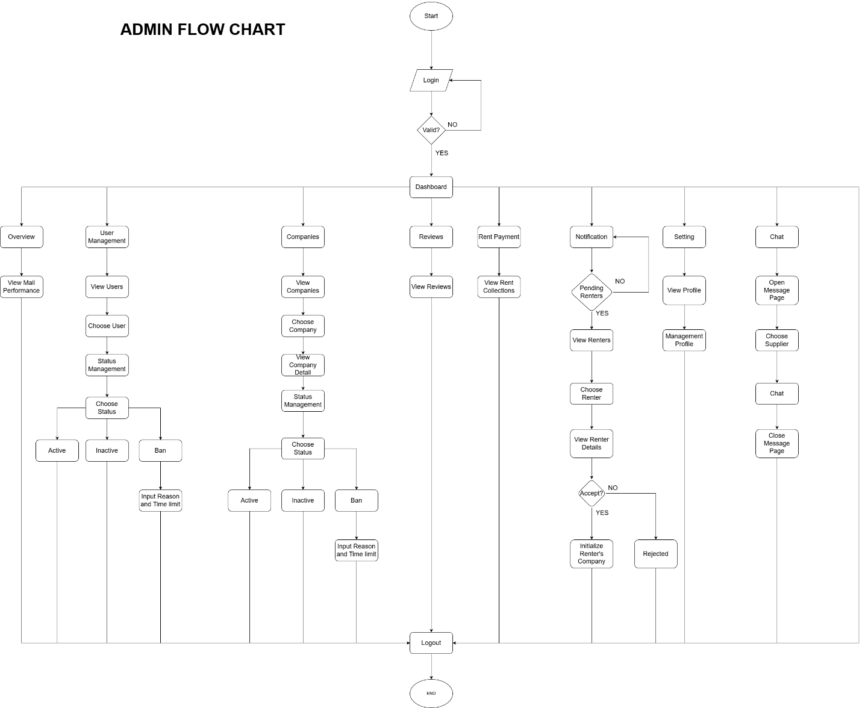

**7.2.1. Supplier Authentication FlowChart**

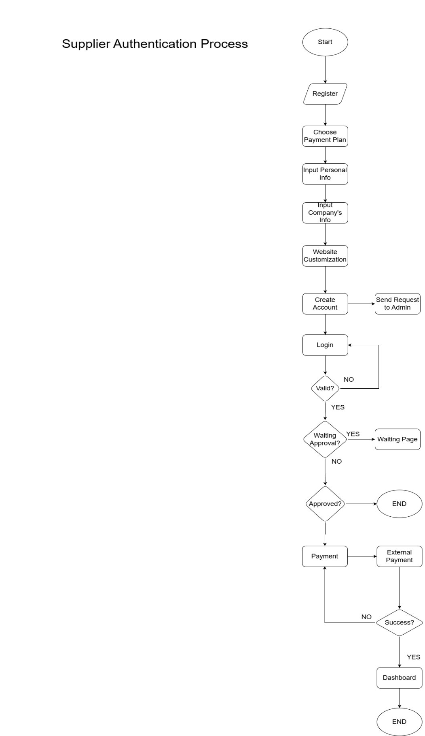

**7.2.2. Supplier FlowChart**

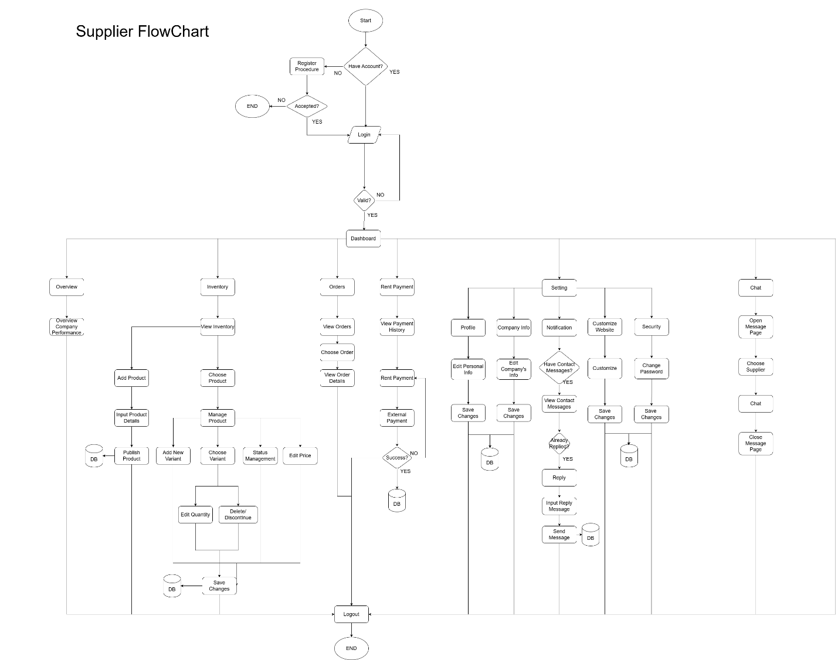

**7.3.1. Customer Authentication FlowChart**

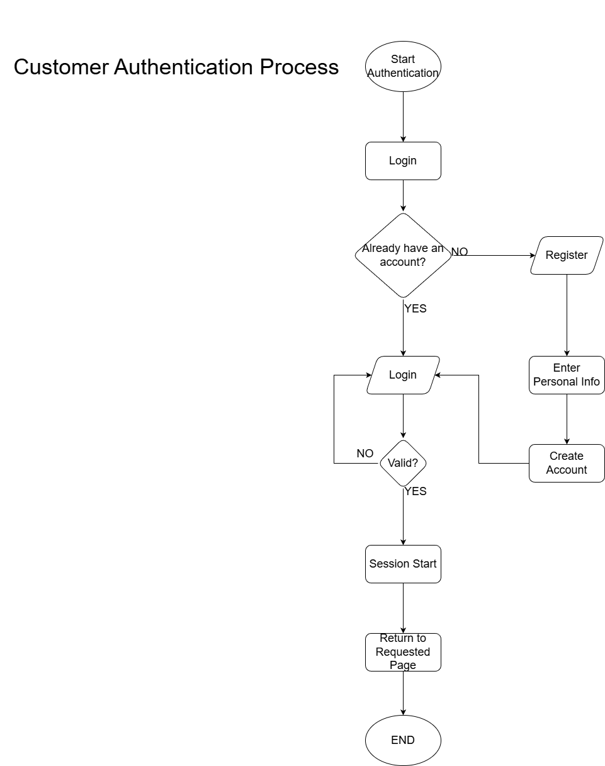

**7.3.2. Customer Authentication FlowChart**

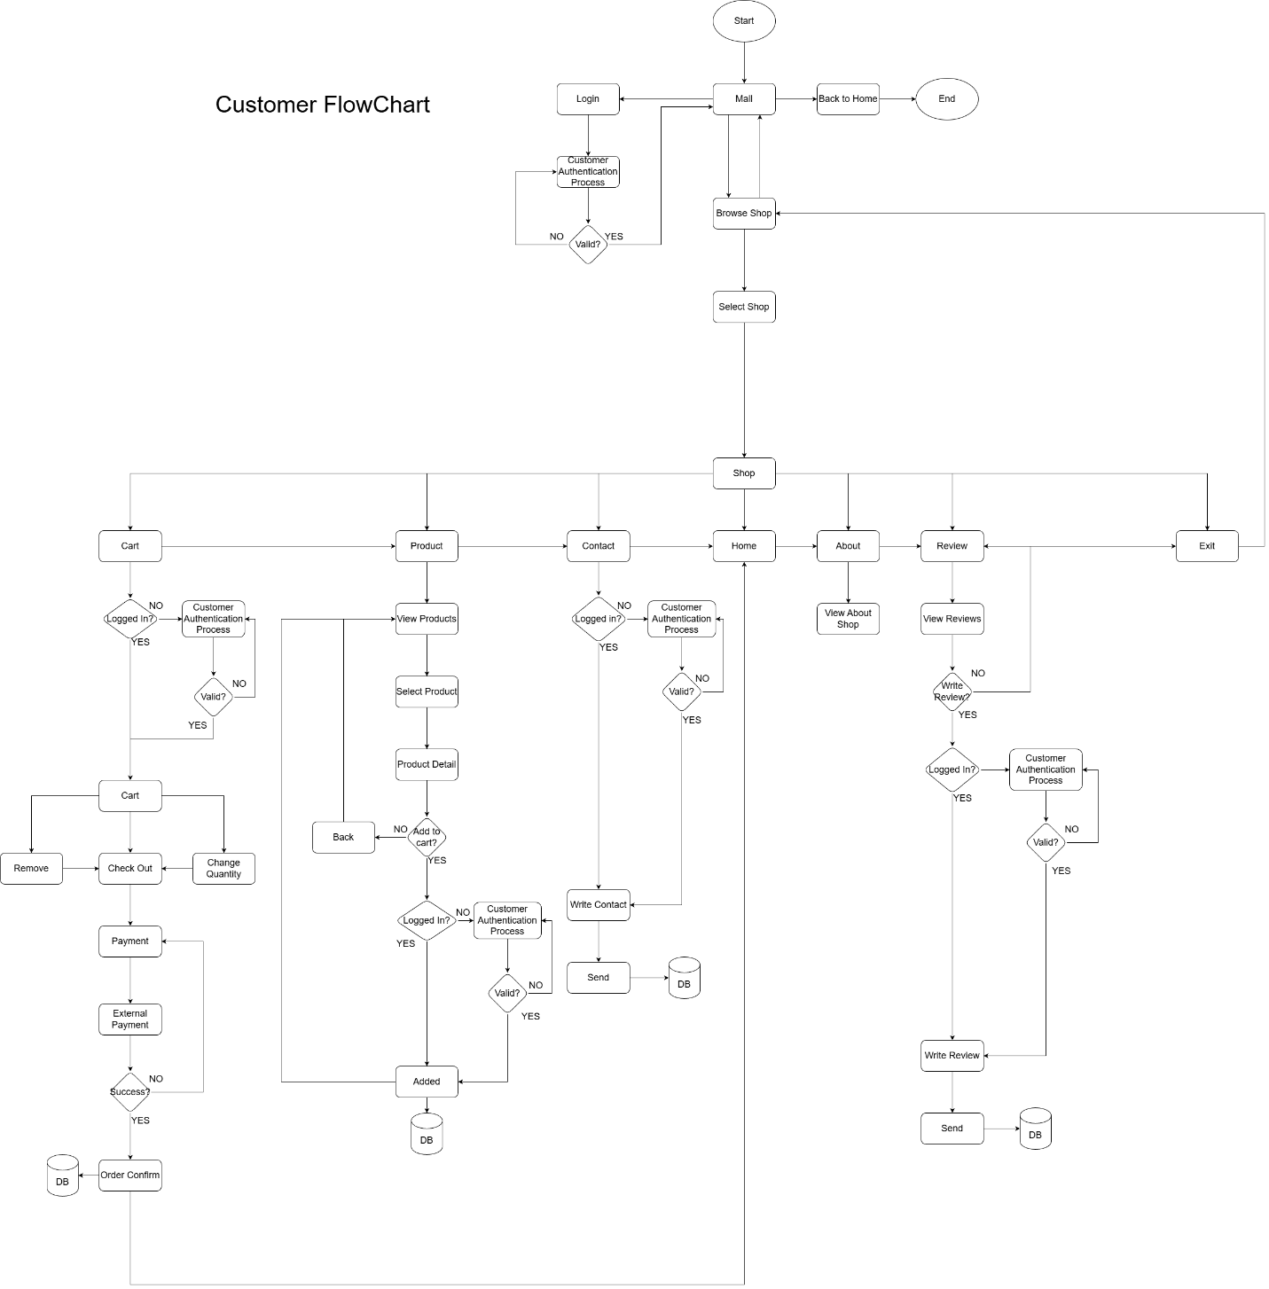

**7.4.1. Admin Use Case**

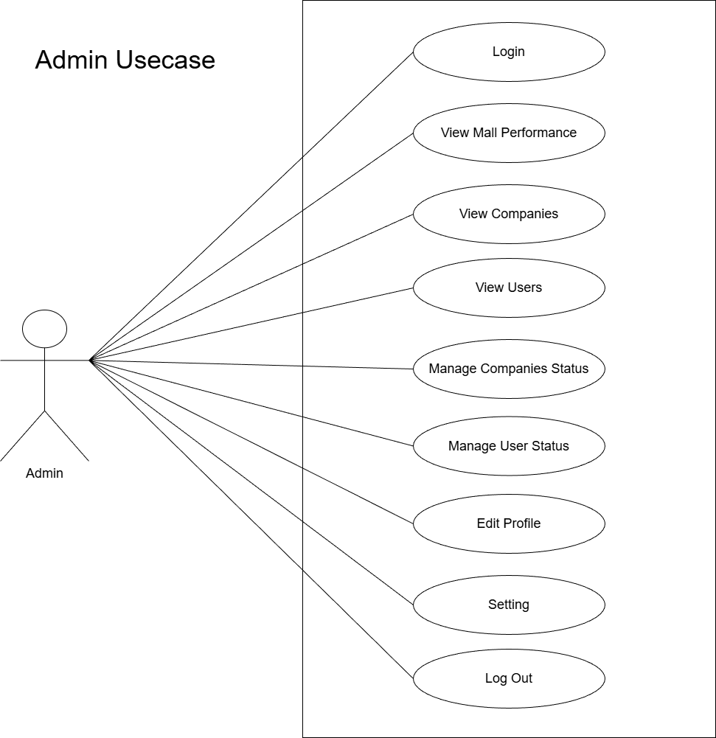

**7.4.2. Supplier Use Case**

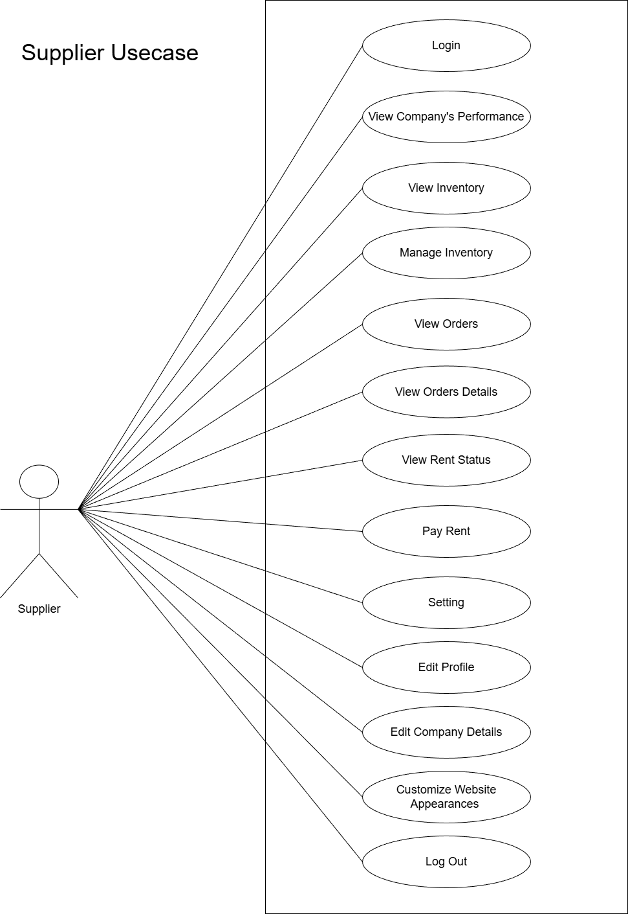

**7.4.3. Customer Use Case**

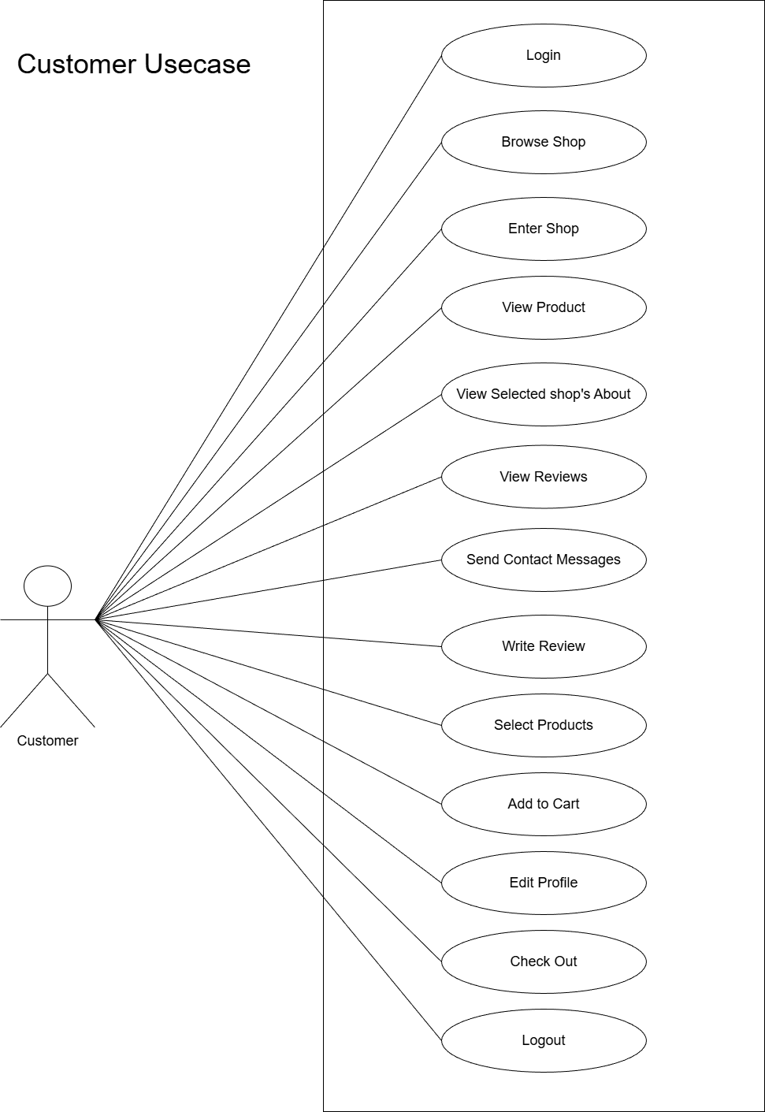

**7.5. Database Schema**

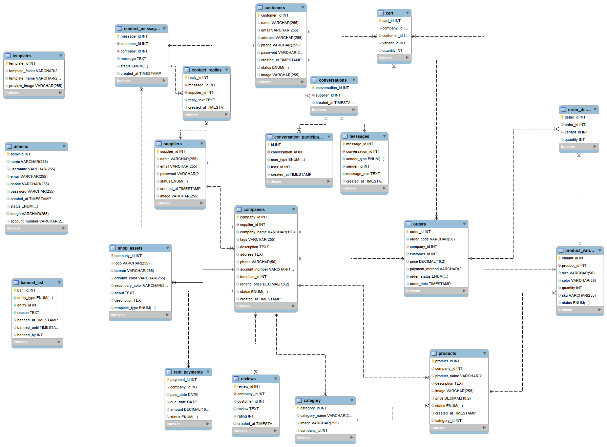

**8.1.1. Admin UI (Admin Dashboard/Overview)**

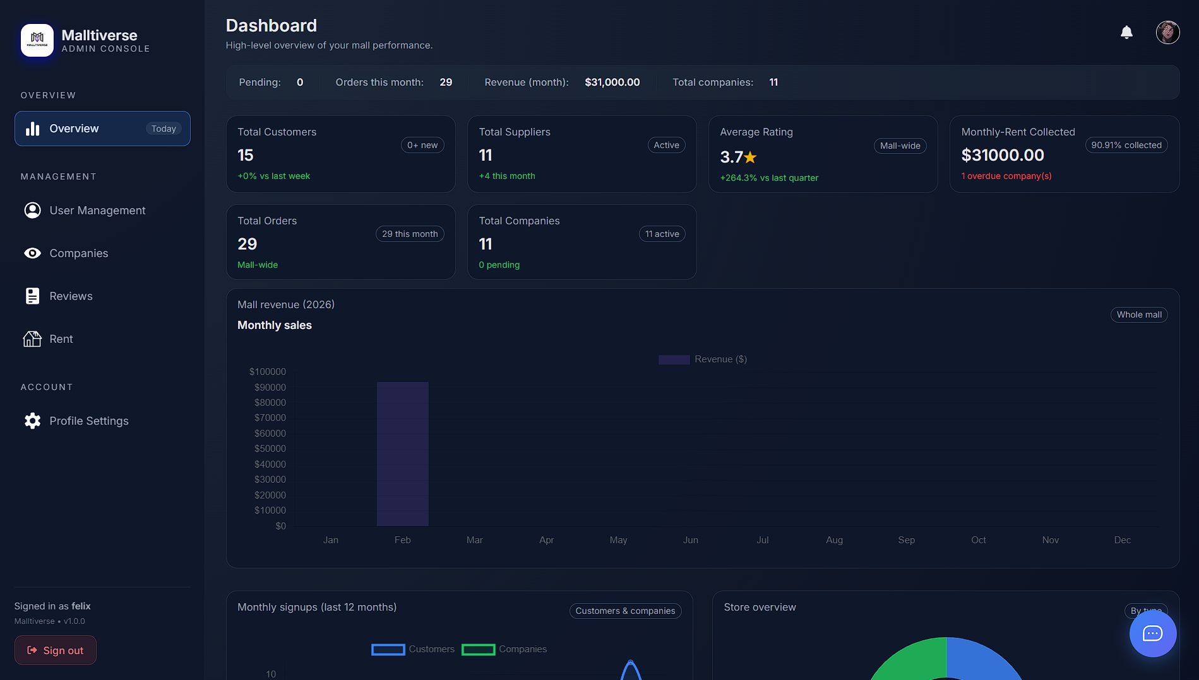

**8.1.2. Admin UI (User Management)**

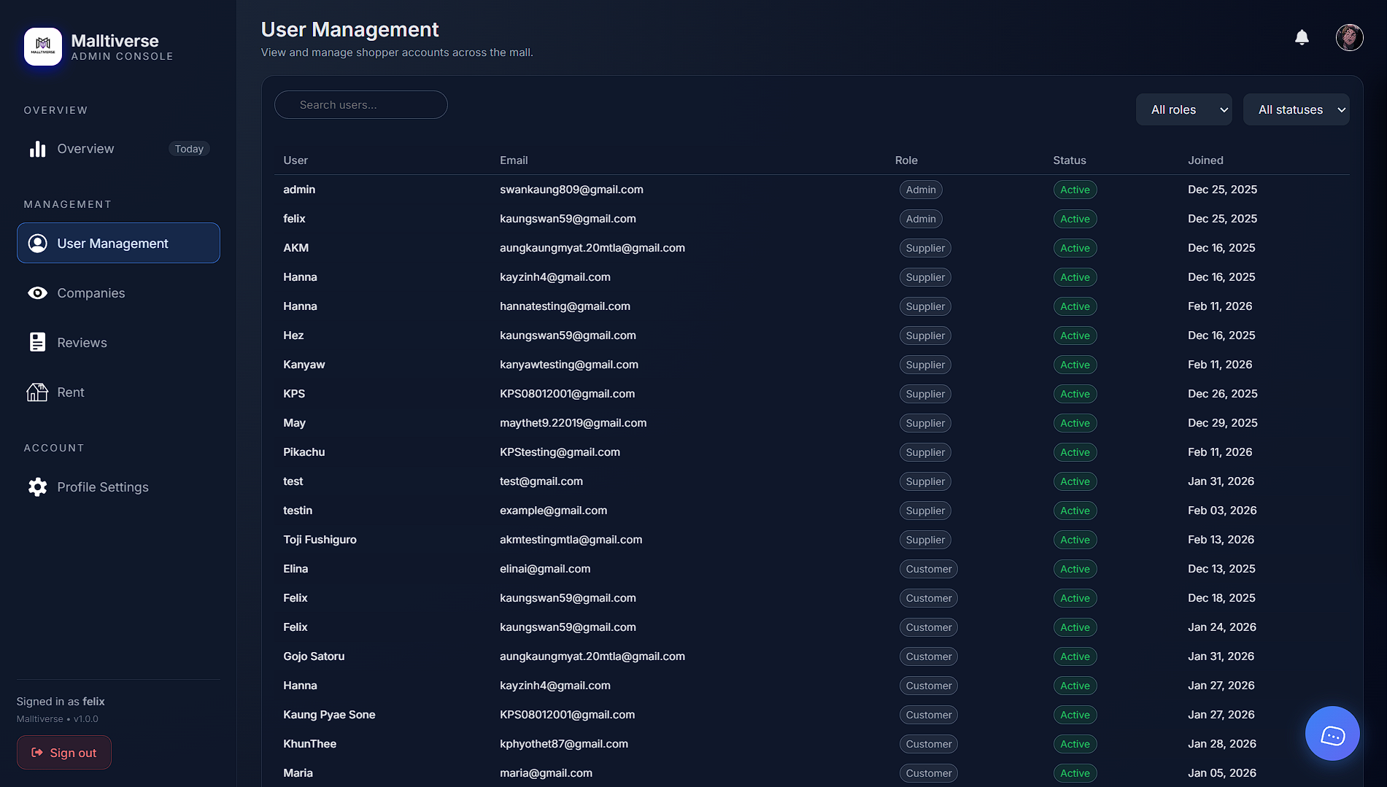

**8.1.3. Admin UI (Companies and Companies Management)**

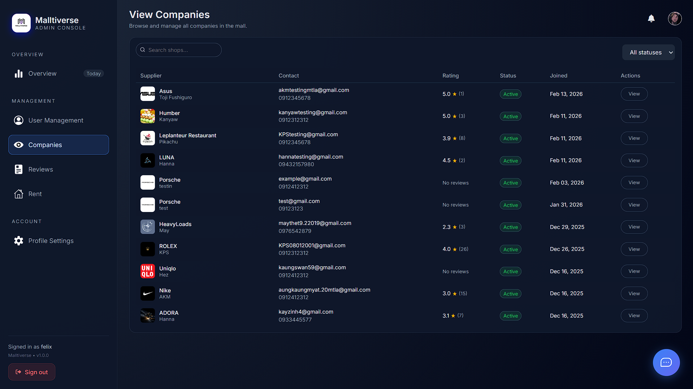

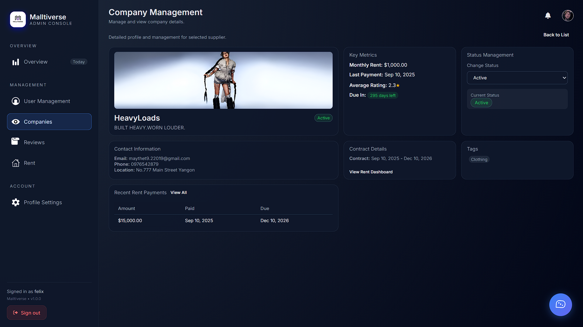

**8.1.4. Admin UI (Reviews)**

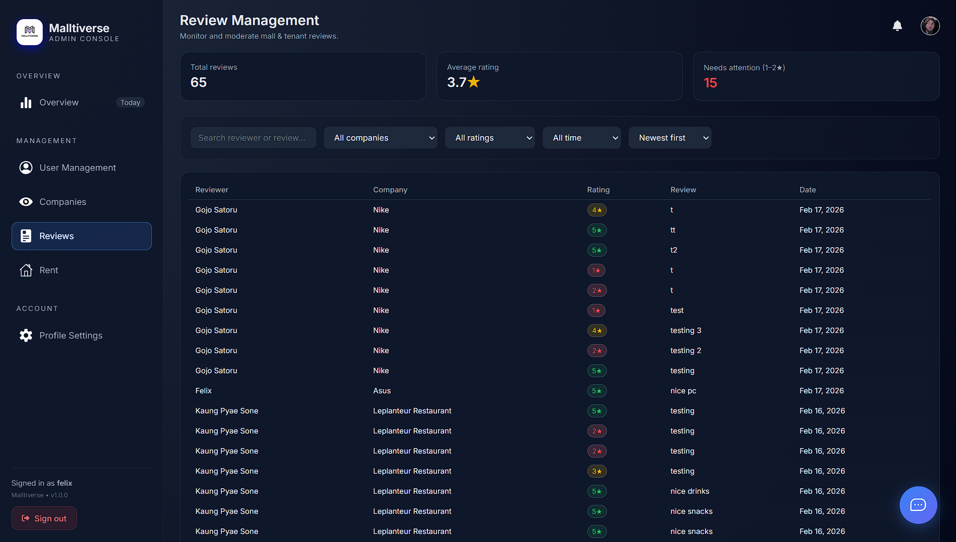

**8.1.5. Admin UI (Rents Management)**

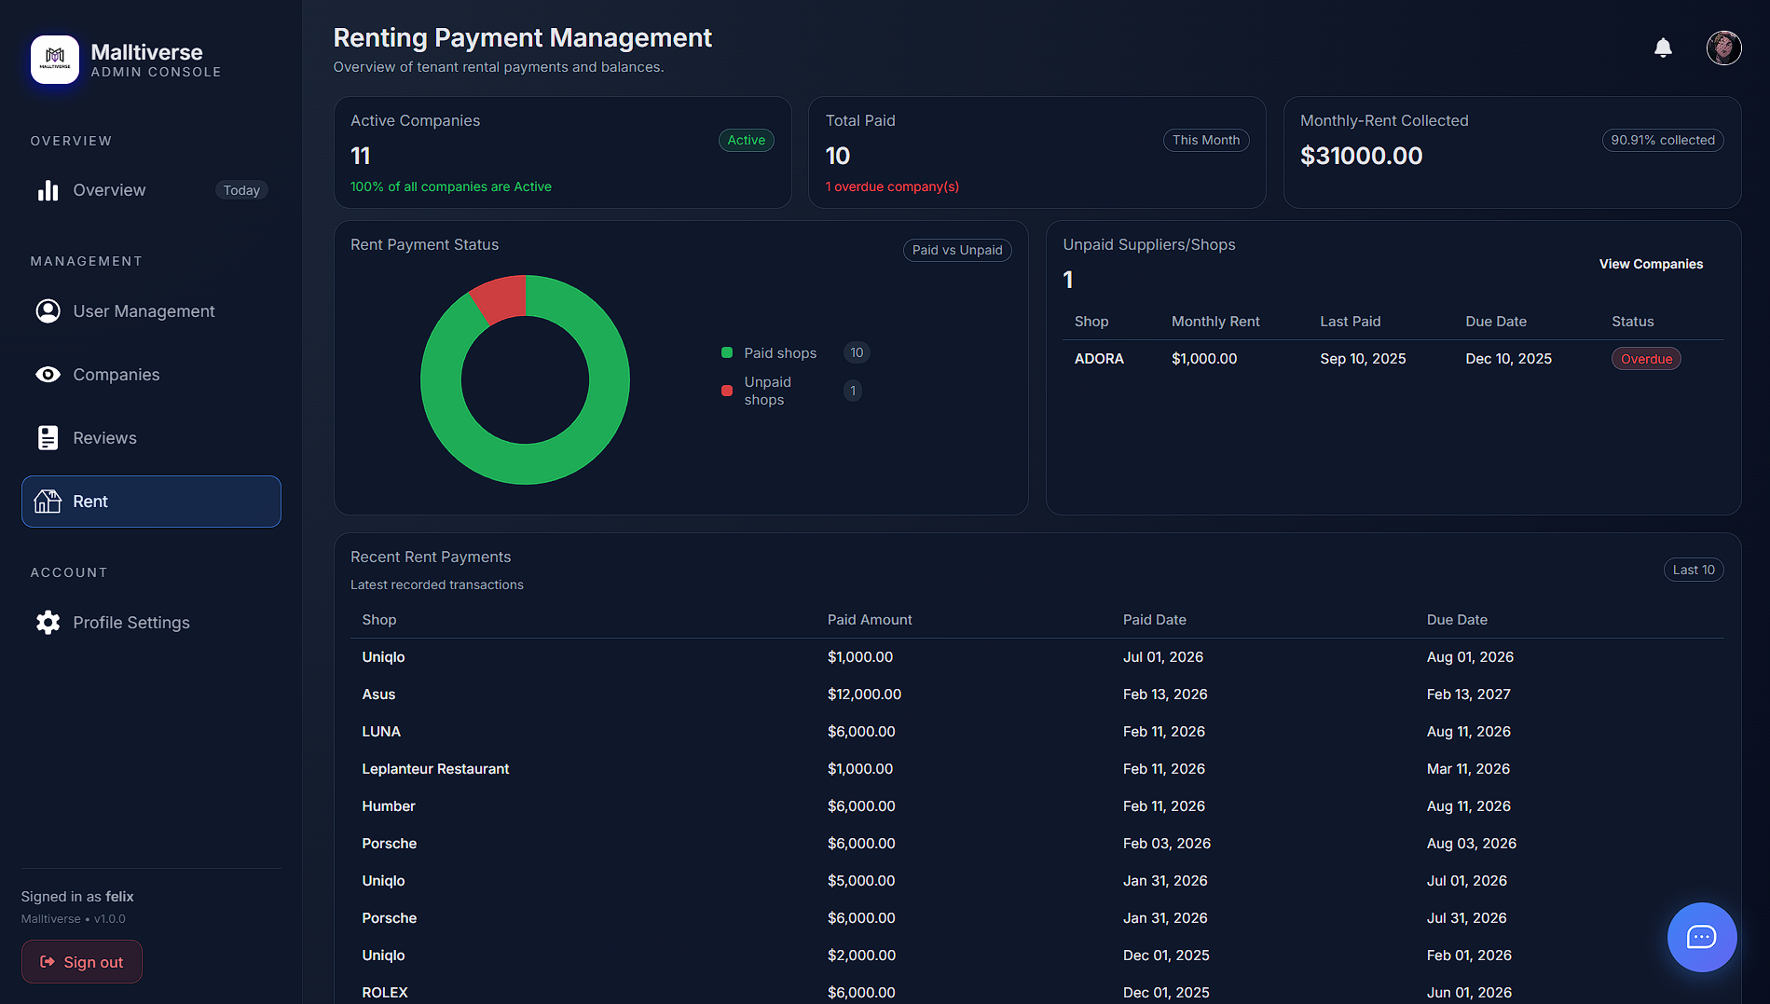

**8.1.6. Admin UI (Settings)**

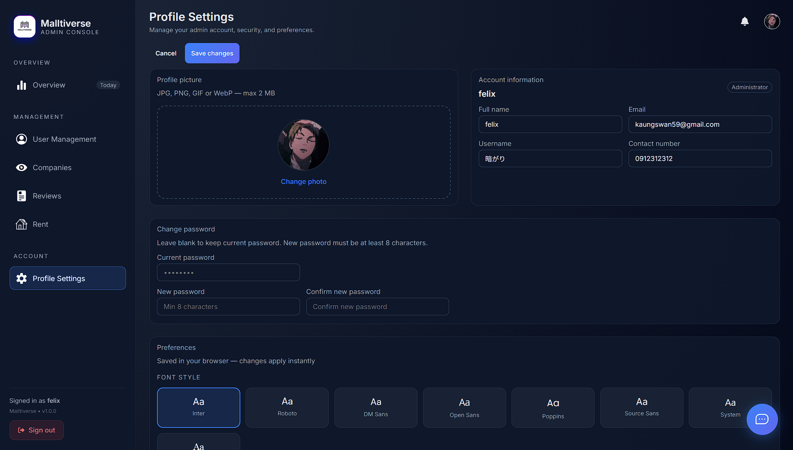

**8.2.1. Supplier UI (Dashboard/Overview)**

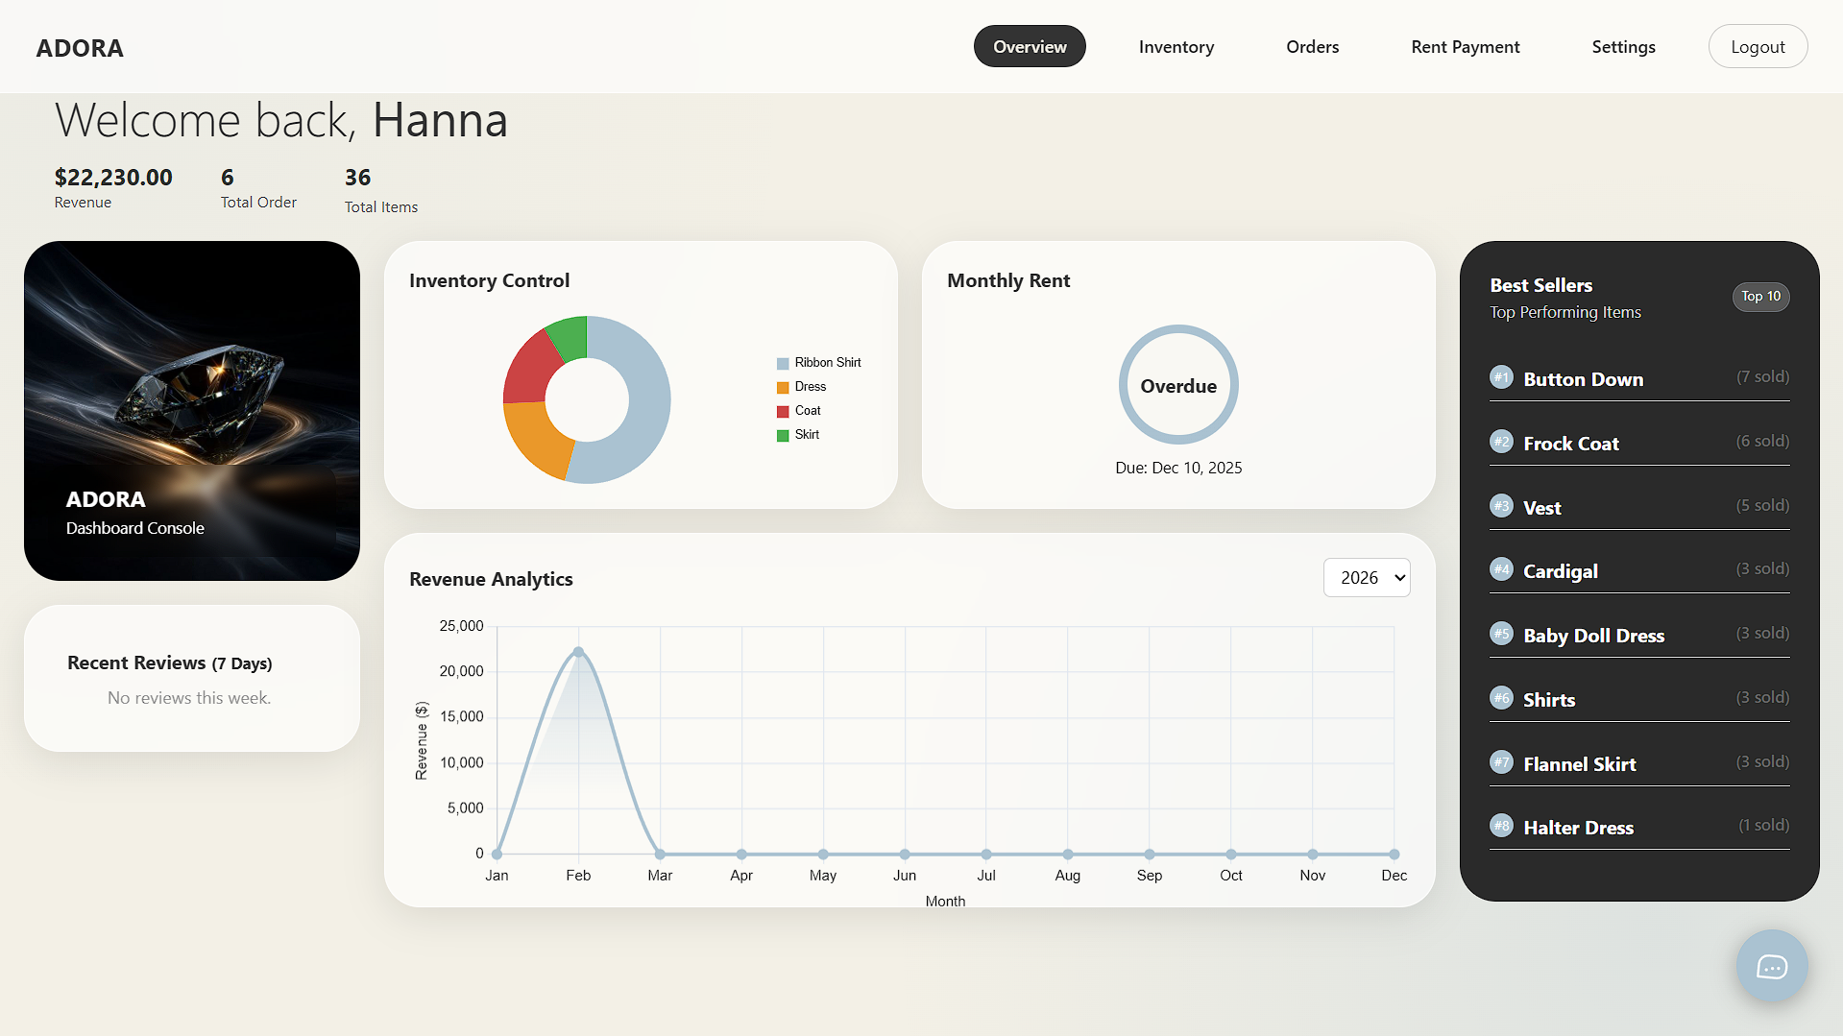

**8.2.2. Supplier UI (Inventory)**

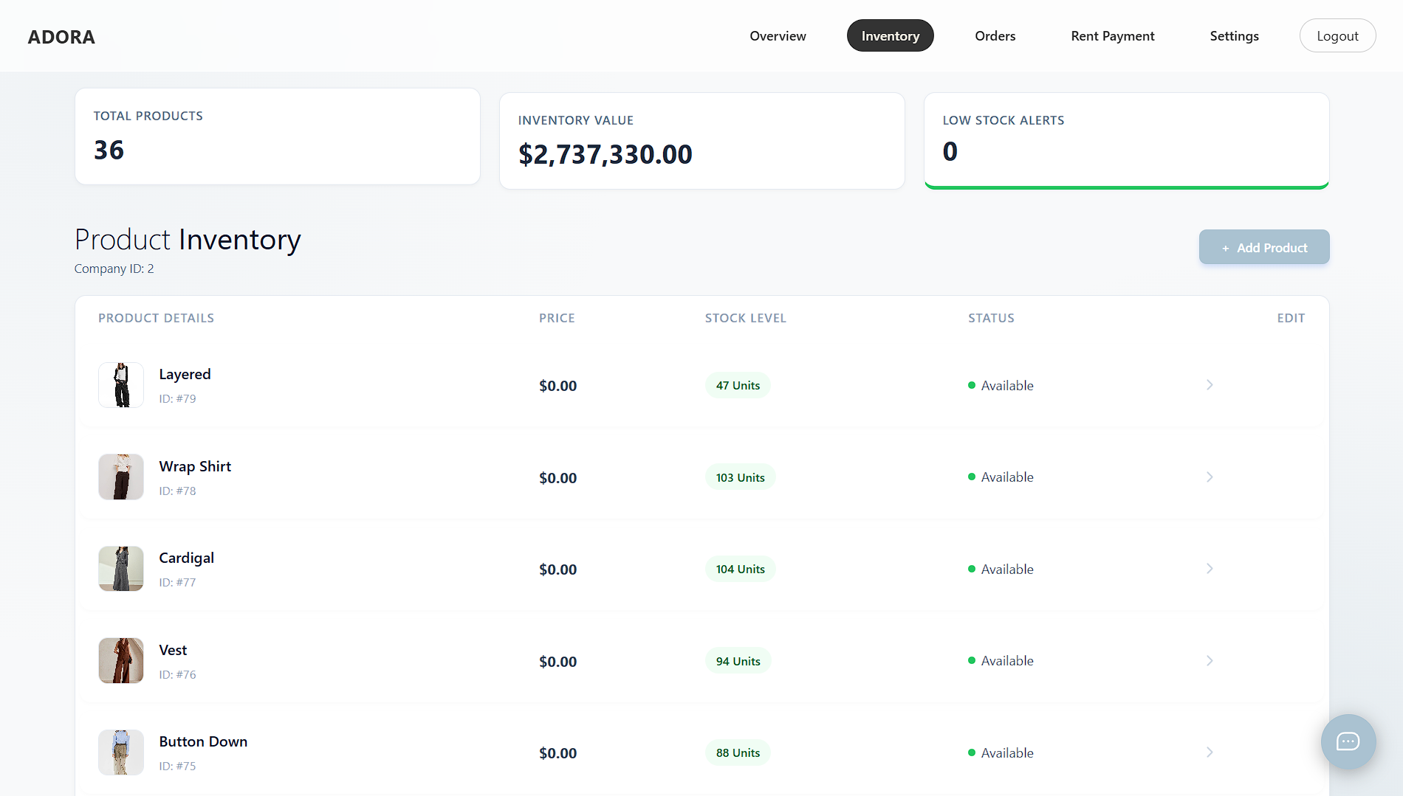

**8.2.3. Supplier UI (Orders)**

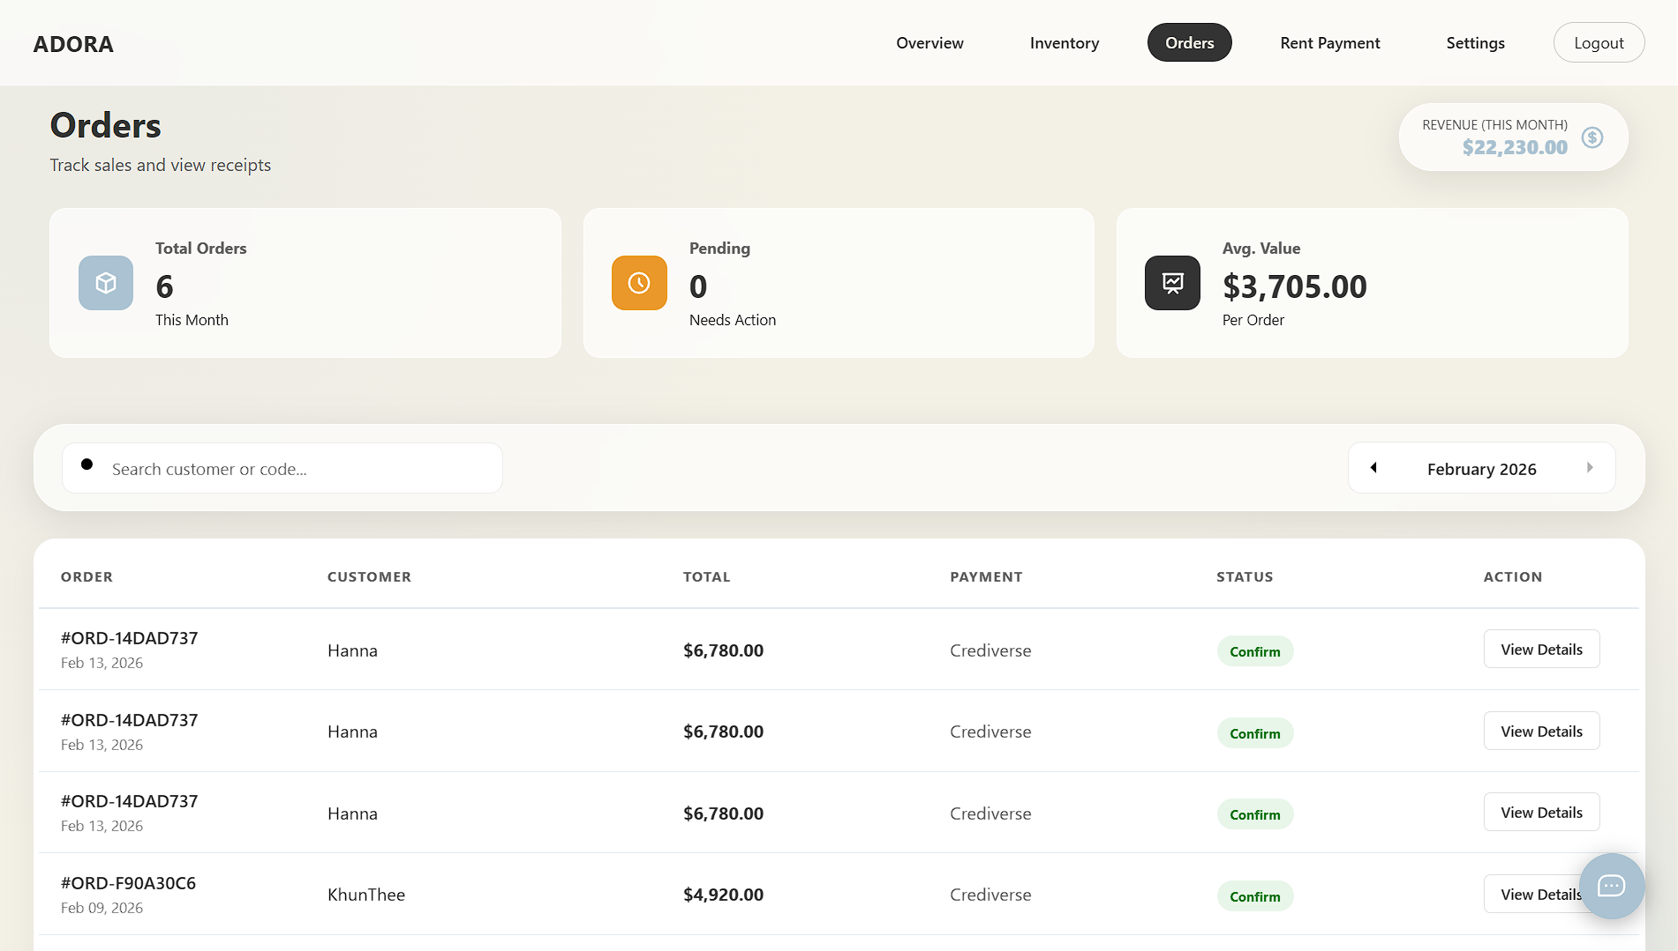

**8.2.4. Supplier UI (Rent Payment)**

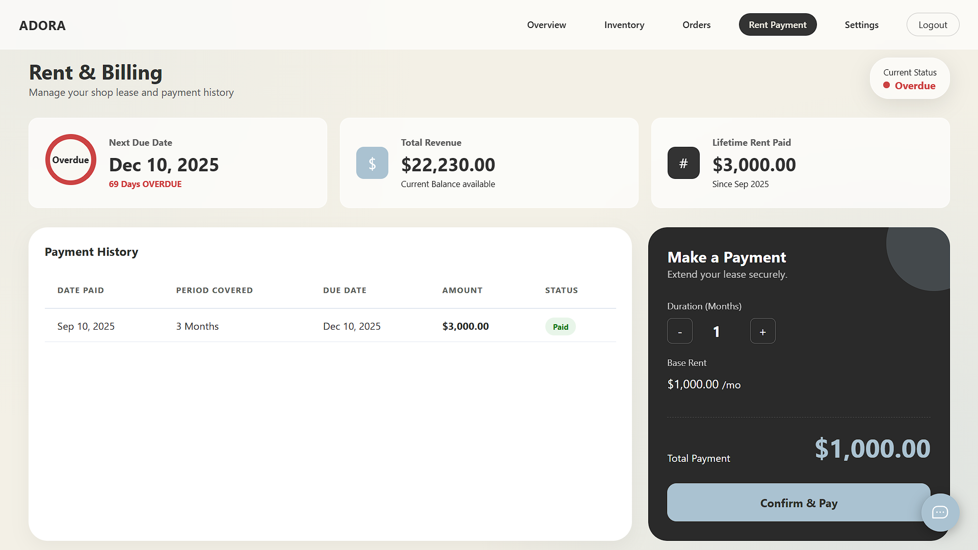

**8.2.5. Supplier UI (Setting)**

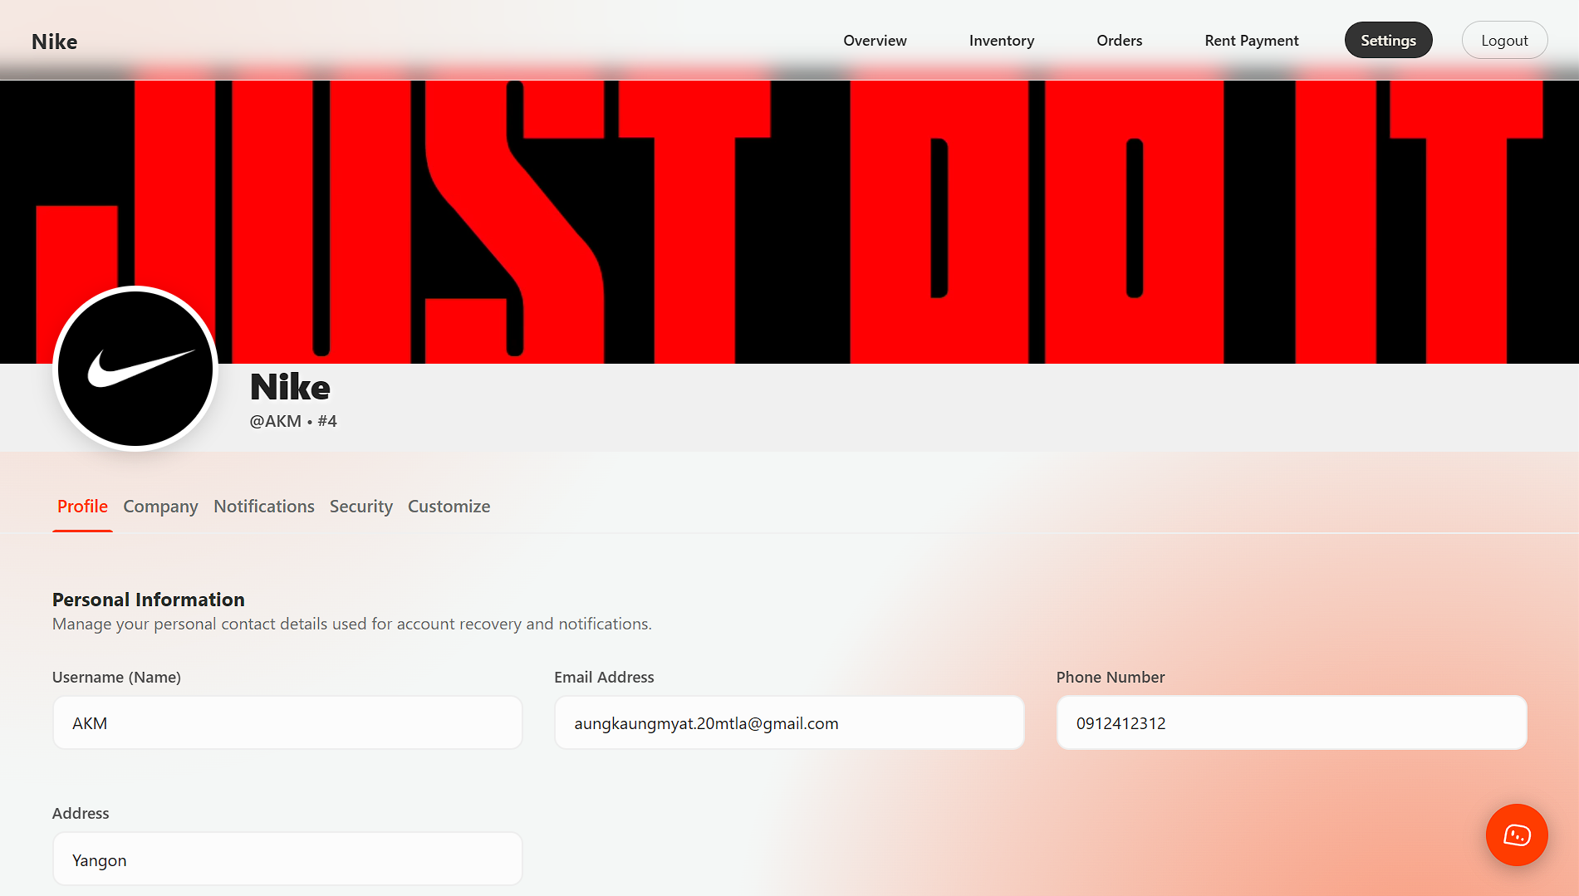

**8.3. User-Side Interface Exclusion**

**The user-side interface designs are excluded from this documentation due to the extensive number of UI implementations within the system. To maintain clarity, readability, and focus, this document emphasizes system functionality, architecture, and core operational components rather than visual interface presentation.**

**9. Conclusion**

The development of Malltiverse demonstrates the successful implementation of a centralized virtual mall platform that integrates customers, suppliers, and administrators into a unified digital environment. The system provides a convenient and interactive online shopping experience while supporting businesses with customizable virtual storefront solutions. Through the use of modern web technologies and immersive design elements, Malltiverse achieves its objective of enhancing accessibility, efficiency, and engagement in e-commerce.

**9.1. Advantages**

- **Centralized Shopping Platform**: Malltiverse allows customers to browse and purchase products from multiple suppliers within a single virtual environment, improving convenience and reducing navigation time across multiple platforms.

- **Immersive User Experience:** The system integrates interactive virtual mall environments using modern web technologies, providing users with a more engaging and realistic shopping experience.

- **Customizable Storefronts:** Suppliers can customize their shop appearance and product displays using different templates, allowing businesses to maintain their branding identity.

- **Secure Authentication and Payment Integration:** The system implements secure login mechanisms, OAuth integration, and a dedicated payment gateway to ensure safe and reliable transactions.

- **Role-Based Access Control:** The platform separates functionalities between customers, suppliers, and administrators, ensuring structured system management and security control.

**9.2. Disadvantages**

**- High System Resource Requirements:** The immersive virtual environment and interactive features may require higher device performance and internet bandwidth, which could affect users with low-end devices.

**9.3. Future Plans**

Although Malltiverse currently provides a comprehensive virtual shopping platform, several enhancements can be implemented to improve system performance, usability, and scalability. Future developments aim to expand system capabilities and provide a more personalized and accessible shopping experience.

* **Performance Optimization:** Enhance system performance by optimizing 3D virtual environments and reducing loading times to support a wider range of devices and internet speeds.
* **AI-Based Product Recommendation:** Introduce artificial intelligence algorithms to recommend products based on customer preferences and browsing history.
* **Global Payment Integration:** Expand payment gateway support to include additional international payment methods to support global transactions.
* **Enhanced Communication Features:** Improve real-time chat systems between customers, suppliers, and administrators for faster issue resolution and customer support.

**10. References**

**1. Crediverse (Custom Payment Gateway)**

Used as the primary payment gateway developed for Malltiverse to handle secure transaction processing, wallet integration, and internal payment functionalities within the platform.

<https://crediverse.base44.app>

**2. UnseenStudio (Custom Payment Gateway)**

Used as a design reference for modern UI/UX concepts, interactive layouts, and visual presentation inspiration during the development of the Malltiverse user interface.

<https://unseen.co>

**3. Google Oauth Authentication**

Used to provide secure and convenient login access through Google account integration, improving user accessibility and authentication security.

**4. Github Oauth Authentication**

Used to implement secure third-party login functionality, allowing users to authenticate and access the system using their GitHub accounts.